
Name_____________Period_______

Homework #16

Designing a logo
The focus of this homework is to analyze, interpret and design a logo. You are to create a logo, which represents one of the following concepts: Face or Smile, Arrow, Letter or Number or Objects.

Points to Remember

You will need to design a logo for TWO of the following ides: Use the examples below for insperation.
Face or smile
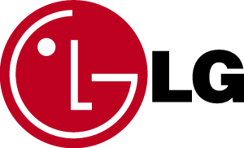

Arrow

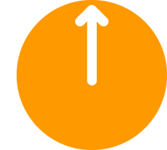

Letter or Number


Objects


- The graphic image should be simple and clearly identifiable
- Incorporate contrast (such as a verity of thickness or making one shape black and another white)
- Incorporate repetition (such as a lines or repeated shapes)

